M.LEENA SAI
BATCH-47_A
AI ASSINGED CODING ASSIGNMENT-1.3
TASK : 1
AI-Generated Logic Without Modularization (Fibonacci Sequence
Without Functions)

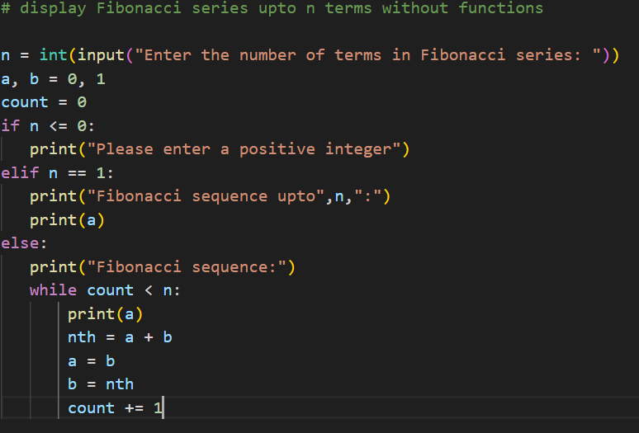

OUTPUT:

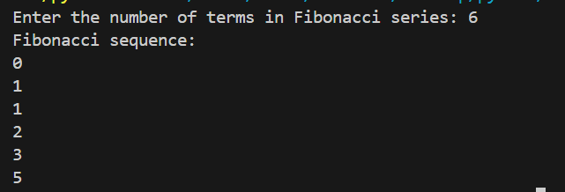
Observation:

This task helped me understand Fibonacci logic clearly without using functions. AI guidance made the code simple and easy to follow.

TASK 2:
AI Code Optimization & Cleanup (Improving Efficiency)

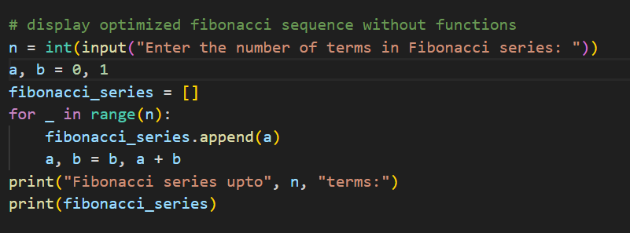

Output:
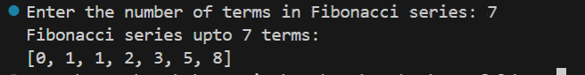

Observation:
This task showed how code optimization makes the Fibonacci program cleaner and more efficient. Using a loop and list improved readability and performance.

Task 3: Modular Design Using AI Assistance (Fibonacci Using Functions)

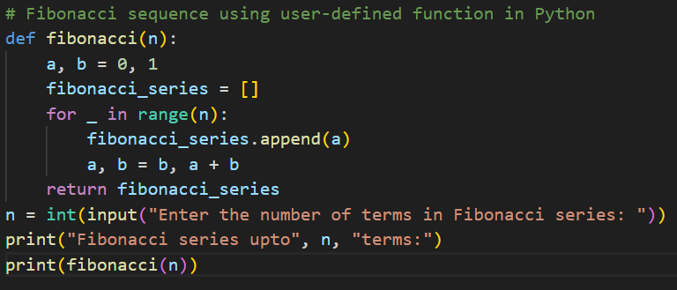

Output:
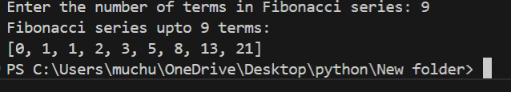

Observation:
By Using functions made the code more organized and reusable. This task helped me understand modular programming clearly.

Task 4: Comparative Analysis – Procedural vs Modular Fibonacci Code
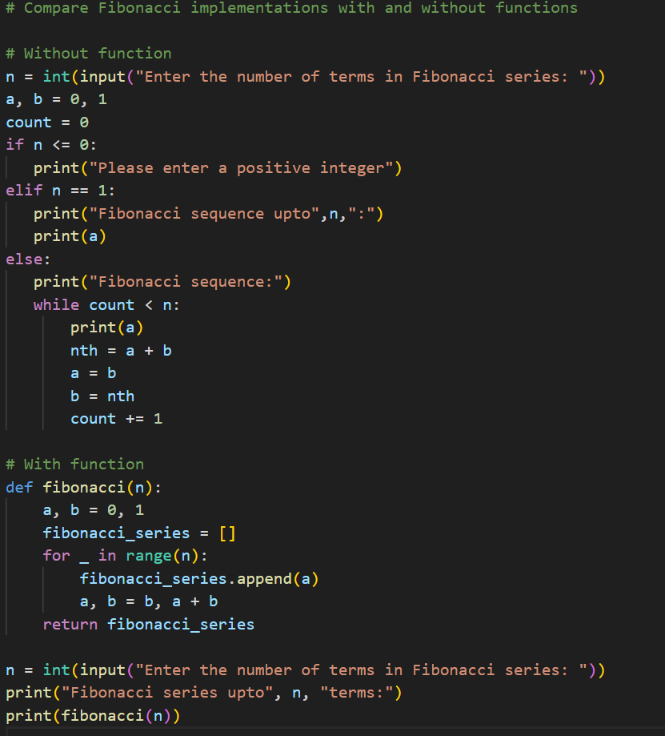

OUTPUT:

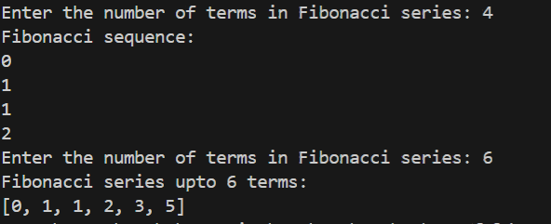
Observation:

This comparison helped me understand the difference between procedural and modular code. Using functions makes the program cleaner and easier to manage.

Task 5: AI-Generated Iterative vs Recursive Fibonacci Approaches (Different
Algorithmic Approaches for Fibonacci Series)

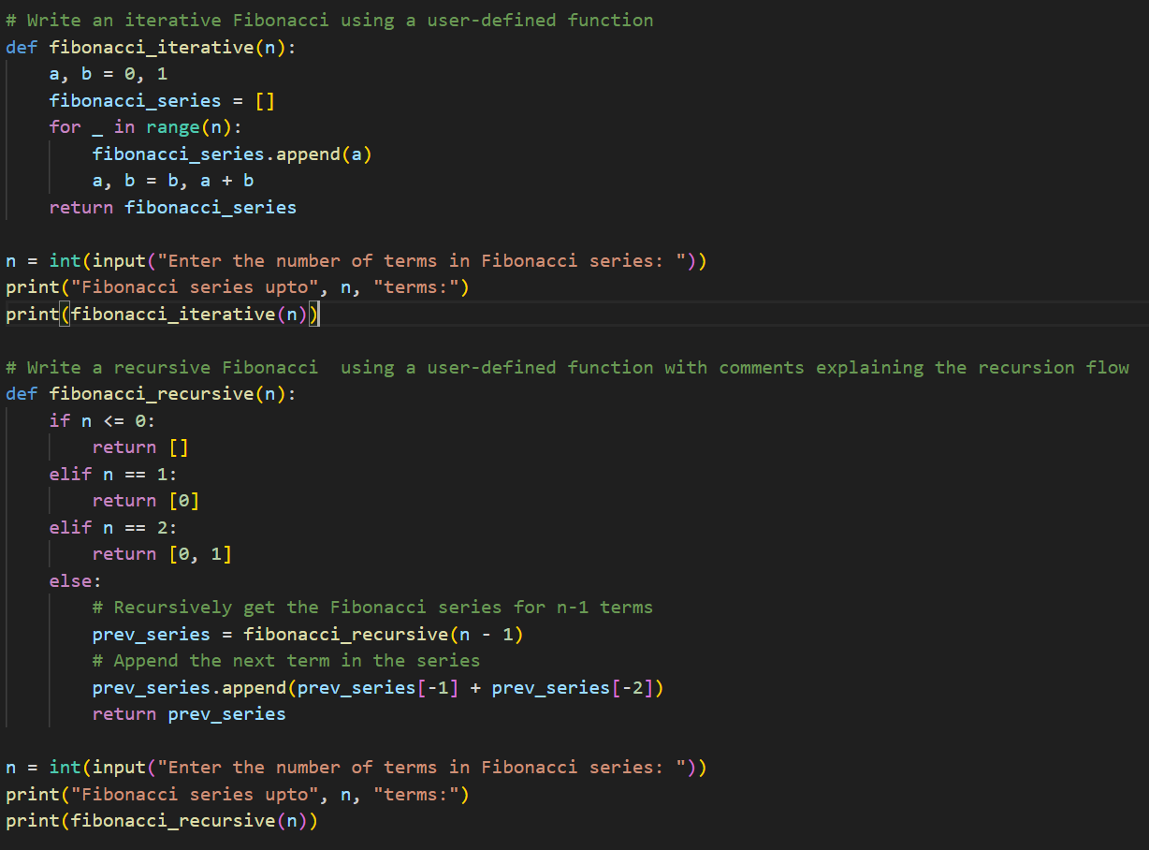
OUTPUT:
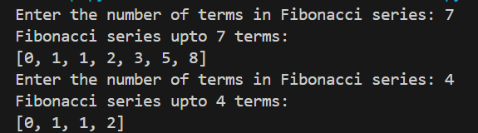

Observation:

This task helped me compare iterative and recursive approaches clearly. I understood how recursion works step by step and why iteration is more efficient.

